Chapter 10, Solution 25.

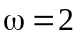
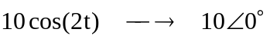
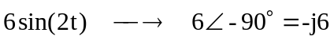
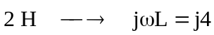
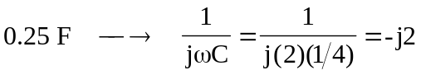

The circuit is shown below.
I_{o}
I₁
j4 
-j2 
4 
+
−
100 V
6-90 V
+
−
I₂

For loop 1,
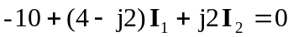
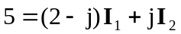 (1)

For loop 2,
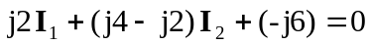
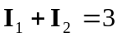 (2)

In matrix form (1) and (2) become
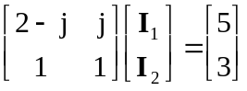

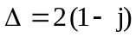, 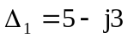, 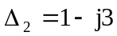

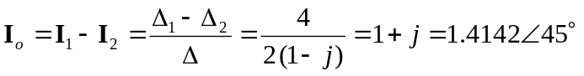
Therefore,
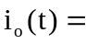 1.4142cos(2t + 45) A

